BSc INFORMATION SYSTEMS AND DATA MANAGEMENT
SOFTWARE ANALYSIS AND TESTING
LABORATORY REPORT
LAB 1 & LAB 2
Student Name: REFILWE JAPPIE
Student Number: 23018035
Module: Software Analysis and Testing
Module Code: COMP 441

LAB 1
DEFECTS LOG
ID | FILE | LINE | DESCRIPTION | SUSPECTED SEVERITY
1 | Grade_manager.py | 95 | Expects a string, but grades uses integers | High
2 | Grade_manager.py | 96 | The report generation crashes since the grades will be numeric | high
3 | Grade_manager.py | 1 | JSON is imported, but it is never used | medium
4 | cli.py | 30 | Attempting to access manager.students[5] while there are only 3 students | high
5 | cli.py | 30 | The hardcoded 5 makes the program less scalable | high
6 | cli.py | 10-12 | Student details are hardcoded instead of being loaded from a file or a database | medium
7 | Grade_manager.py | 46 | The get_average () divides by zero when a student exists but has no grades | high
8 | Grade_manager.py | 47 | It does not check for an empty grade before calculating the average | high

Screenshot of installed tool versions
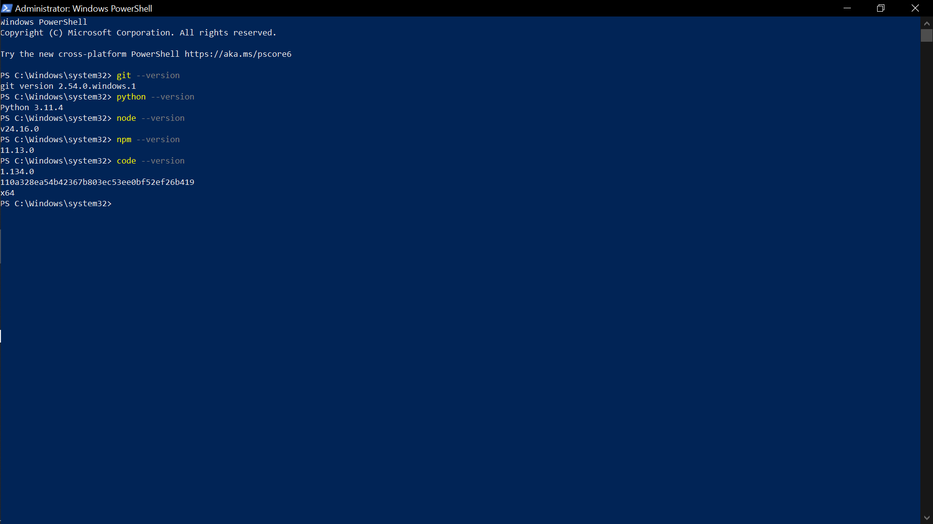
AI Assistant Used: ChatGPT (Free Tier). The assistant was tested by asking it to analyze the Student Grade Manager repository and identify potential defects. The assistant successfully identified logic, runtime, and code-quality issues, confirming that it was properly configured and usable for later labs.
DISCUSSION
The most useful findings were the dangerous default argument, the division-by-zero defect, and the TypeError in the report generation method. These issues are important because they can cause incorrect program behaviour or runtime failures.
Pylint was useful for identifying code-quality and style issues. However, manual inspection and AI-assisted review were able to identify deeper logical and runtime problems that were not necessarily reported by the linter.
This showed that different analysis methods can identify different types of defects. Therefore, using a combination of static analysis, manual review, and AI-assisted review provides better coverage than relying on one method alone.

LAB 2
BEFORE FIXES
1. PYLINT FINDINGS
Grade_manager.py
ID | TYPE | DESCRIPTION
1 | Convention | Consider using enumerate
2 | Convention | Consider using enumerate
3 | Warning | Dangerous default value [] as an argument
4 | Warning | Unused import json
5 | Convention | Trailing whitespace
Code is rated 8.00/10
AFTER FIXES
**Module grade_manager
grade_manager.py:11:45: C0303: Trailing whitespace (trailing-whitespace)
grade_manager.py:25:33: C0303: Trailing whitespace (trailing-whitespace)
grade_manager.py:60:53: C0303: Trailing whitespace (trailing-whitespace)
grade_manager.py:71:29: C0303: Trailing whitespace (trailing-whitespace)
grade_manager.py:96:57: C0303: Trailing whitespace (trailing-whitespace)
grade_manager.py:110:8: C0200: Consider using enumerate instead of iterating with range and len (consider-using-enumerate)

------------------------------------------------------------------
Your code has been rated at 8.64/10 (previous run: 8.00/10, +0.64)
2. COMPLEXITY ANALYSIS (RADON)
Function | Complexity | Rank
Grademanager.get_passing_students | 4 | A
Grademanager | 3 | A
Grademanager.add_grade | 3 | A
Grademanager.get_average | 3 | A
Grademanager.format_report | 3 | A
Grademanager.remove_student | 3 | A
Grademanager.get_all_students | 2 | A
Grademanager. __init__ | 1 | A
Grademanager.add_student | 1 | A
cli.py
main | 4 | A

3. TRIAGE REPORT
Finding | Severity | Fix Effort
- Dangerous default value [] | Critical | High
- Unused import json | Medium | low
- Duplicate student allowed | Medium | High
- Missing grade validation | Medium | High
- Trailing whitespace | Low | Low
- Hardcoded student records | Medium | Low
- Direct access to internal student list | Medium | Medium
- Use of range(len ()) | Low | High

THREE FIXED ISSUES

Issues | Before | After | Why
Dangerous Default Argument | def add_student(self, name, grades=[]): | def add_student(self, name, grades=None):  if grades is None:  grades = [] | Using [] as a default value can cause multiple function calls to share the same list unexpectedly.
Unused Import | import json | Removed unused import | The json module is never used anywhere in the file.
Range + len Loop | names = []  for i in range(0, len(self.students)):  names.append(self.students[i]["name"])  return names | names = [] for student in self.students:  names.append(student["name"])  return names | The new version is simpler, easier to read, and avoids unnecessary indexing.

4. COMPARISON TABLE
Snippet 1
def add_student(self, name, grades=[]):
Analysis | Result
Pylint | Detected the dangerous default argument
AI Code Review | Detected the dangerous default argument and explained why it could cause shared-list behaviour

Snippet 2
grades_str = ", ".join(student["grades"])
Analysis | Result
Pylint | Did not identify the runtime problem
AI Code Review | Identified the possible TypeError

DISCUSSION
The exercise showed that a high linter score and low cyclomatic complexity do not guarantee correct behaviour. The initial program scored 8.00/10 and every measured function was in risk band A, yet it still contained defects capable of producing incorrect results or runtime exceptions. Pylint was effective at consistently identifying a mutable default argument, formatting issues, and iteration style. Manual and AI-assisted review added requirement-aware reasoning, particularly for the reversed passing condition and the empty-grade calculation.
The failed after-fix run also demonstrated an important engineering lesson: every edit must be validated first for syntax and structure before interpreting quality metrics. A static analyzer can reveal when a repair introduces new defects, but the developer must distinguish original findings from repair-induced errors. The best workflow is therefore baseline analysis, small controlled fixes, syntax/test checks, a clean rerun, and documented comparison.

